**EXPERIMENT 5**

DDL COMMANDS (COLLEGE SCHEMA)

**Aim:**

* Create a schema called College.
* Create tables for students (attributes: student id, name, gender, subject, marks and grade), faculty (attributes: faculty id, name, course and pass percentage), department (attributes: department id, name, section, strength and pass percentage) and activity (attributes: activity id, name, strength and category)
* Add and modify:
  + Address in students table, change datatype size of student name and make student id primary key
  + Add faculty total mentor details, make faculty id as primary key
  + Add number of students in wise in department table and make department id as primary key
  + Add faculty name to activity table, change the datatype size of activity name and make activity id as primary key

**Queries:**

* Create Schema College;
* Create table - Student and attributes are studid, studname, gender, subject, marks, grade
* Create table - Faculty and attributes are fac_id, fac_name, course, pass_percentage
* Create table – Department and attributes are dept_no, dept_name, section, no_of_students, pass_percentage
* Create table – Activity and attributes are act_id, act_name, no_of_students

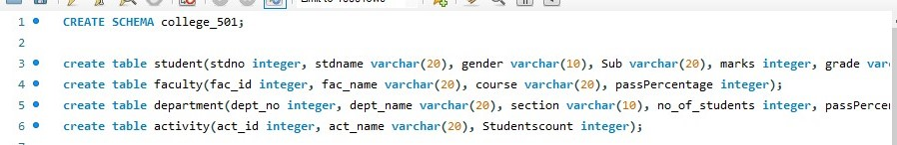

* Add address in student table, change the datatype size for student name and make studid as primary key
* Add faculty total mentor details, make fac_id as primary key
* Add no of students in wise and make dept no as primary key
* Add faculty name and change the size act_name and act_id as primary key

